DATABASE SYSTEMS ENGINEERING AND DISTRIBUTED BACKEND DEVELOPMENT(25CS1302E)

LAB MANUAL

- A working REST API running on day one — students issue HTTP requests with curl and Postman and observe the round trip before any internals.The canonical backend stack: HTTP server → routing/middleware → service layer → data-access layer → ORM/JDBC → SQL → storage engine → filesystem.REST as a discipline: resources, HTTP verbs, status codes, idempotence, statelessness; the contract a backend exposes to its clients.Spring Boot at intro level: the @RestController, @Service, @Repository layering; dependency injection at use-site, not theory.

Case Study: Student Management REST API
- Develop a REST API to manage students in a college. The API should allow clients (Postman/cURL) to perform CRUD operations.

Backend Architecture:
HTTP Request
│
▼
@RestController
│
▼
@Service
│
▼
@Repository
│
▼
Spring Data JPA
│
▼
MySQL Database

Project Structure:
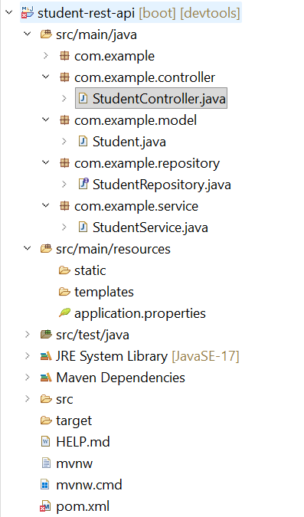
Step 1:
- Open SpringBoot workspace
- Create New Spring Starter Project student-rest-api
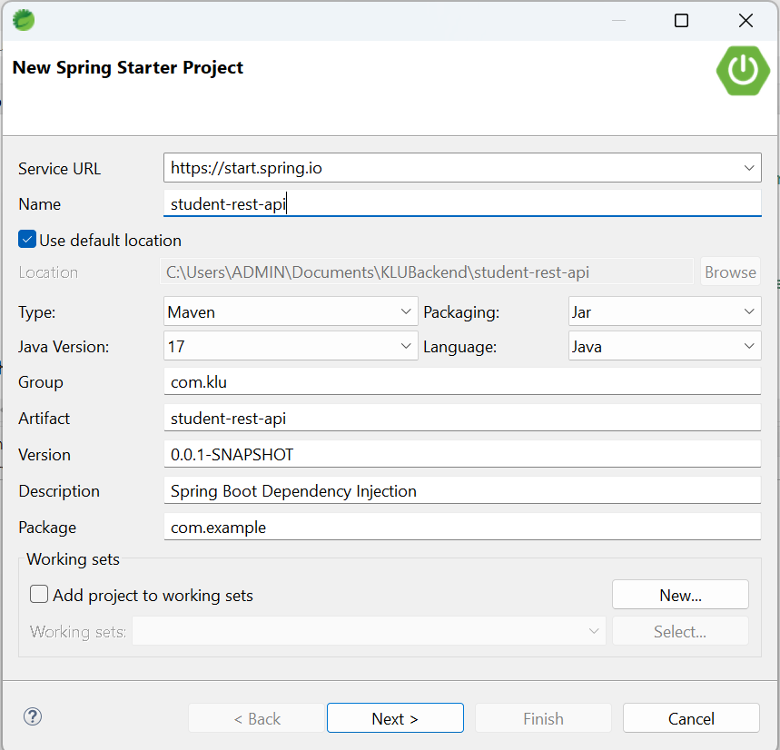
- Next, select dependencies Spring Boot DevTools, Spring Data JPA, Spring Web, MySQL Driver.
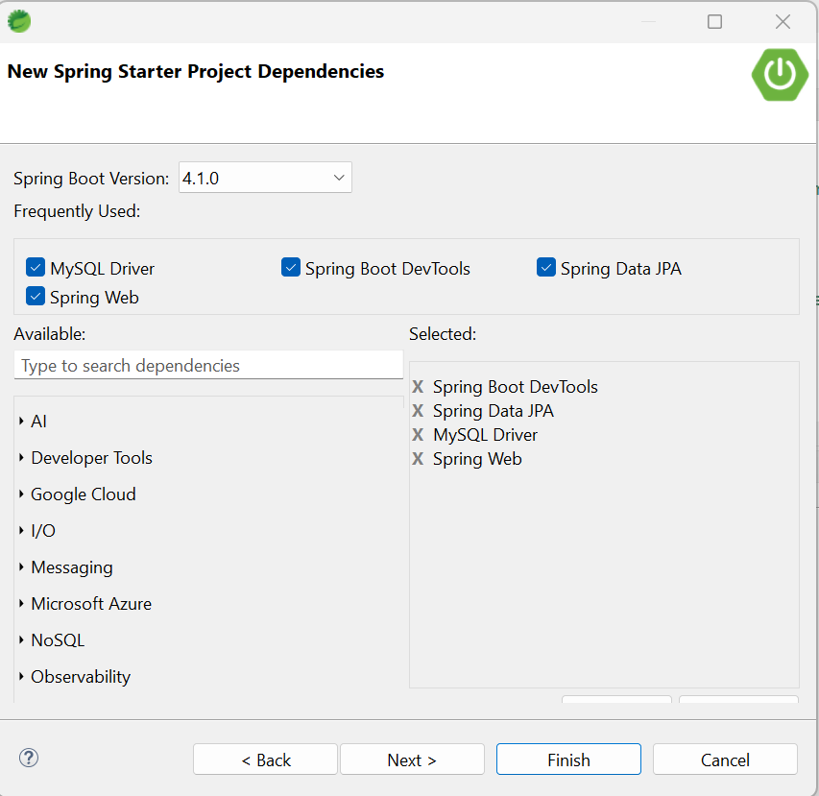
- Click on Next and Finish.
Step 2:
Add Dependencies in pom.xml file and save the file
<?xml version="1.0" encoding="UTF-8"?>
<project xmlns="http://maven.apache.org/POM/4.0.0" xmlns:xsi=http://www.w3.org/2001/XMLSchema-instance xsi:schemaLocation="http://maven.apache.org/POM/4.0.0 http://maven.apache.org/xsd/maven-4.0.0.xsd">
<modelVersion>4.0.0</modelVersion>
<parent>
<groupId>org.springframework.boot</groupId>
<artifactId>spring-boot-starter-parent</artifactId>
<version>4.1.0</version>
<relativePath/> <!-- lookup parent from repository -->
</parent>
<groupId>com.klu</groupId>
<artifactId>student-rest-api</artifactId>
<version>0.0.1-SNAPSHOT</version>
<name>student-rest-api</name>
<description>Spring Boot Dependency Injection</description>
<url/>
<licenses>
<license/>
</licenses>
<developers>
<developer/>
</developers>
<scm>
<connection/>
<developerConnection/>
<tag/>
<url/>
</scm>
<properties>
<java.version>17</java.version>
</properties>
<dependencies>
<dependency>
<groupId>org.springframework.boot</groupId>
<artifactId>spring-boot-starter-data-jpa</artifactId>
</dependency>
<dependency>
<groupId>org.springframework.boot</groupId>
<artifactId>spring-boot-starter-webmvc</artifactId>
</dependency>
<dependency>
<groupId>org.springframework.boot</groupId>
<artifactId>spring-boot-devtools</artifactId>
<scope>runtime</scope>
<optional>true</optional>
</dependency>
<dependency>
<groupId>com.mysql</groupId>
<artifactId>mysql-connector-j</artifactId>
<scope>runtime</scope>
</dependency>
<dependency>
<groupId>org.springframework.boot</groupId>
<artifactId>spring-boot-starter-data-jpa-test</artifactId>
<scope>test</scope>
</dependency>
<dependency>
<groupId>org.springframework.boot</groupId>
<artifactId>spring-boot-starter-webmvc-test</artifactId>
<scope>test</scope>
</dependency>
</dependencies>
<build>
<plugins>
<plugin>
<groupId>org.springframework.boot</groupId>
<artifactId>spring-boot-maven-plugin</artifactId>
</plugin>
</plugins>
</build>
</project>
Step 3:
In application.properties file,
spring.application.name=student-rest-api
spring.datasource.url=jdbc:mysql://localhost:3306/studentdb
spring.datasource.username=root
spring.datasource.password=root
spring.jpa.hibernate.ddl-auto=update
spring.jpa.show-sql=true
server.port=8085
Step 4:
Create Packages, Model, Controller, Service, Repository in src/main/java
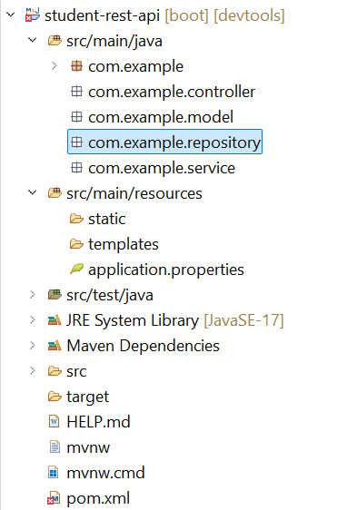
Step 5:
In com.example.model Layer, create the class file student.java and save it
this.name=name;
}
public String getDepartment() {
return department;
}
public void setDepartment(String department) {
this.department=department;
}
public String getEmail() {
return email;
}
public void setEmail(String email) {
this.email=email;
}
}
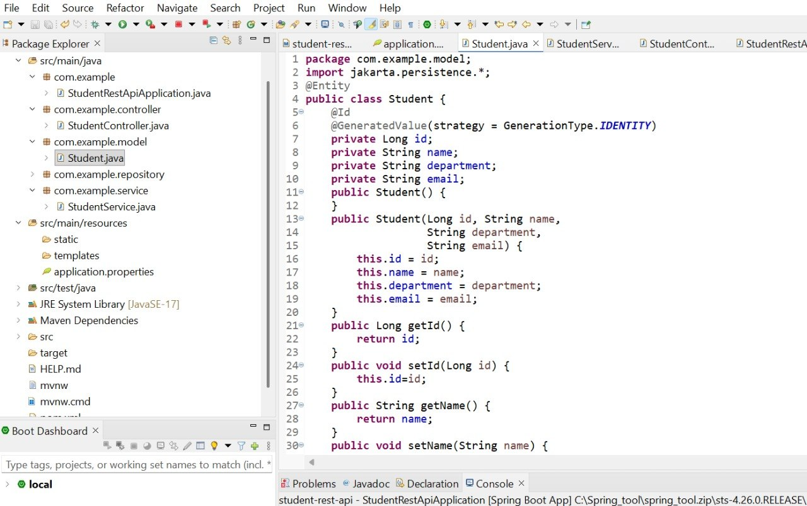
Step 6:
Create class file StudentRepository.java in com.example.Repository Layer and save it.
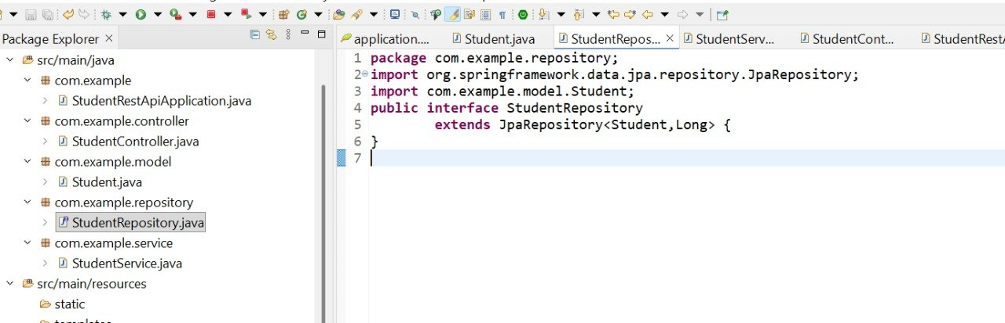

Step 7:
Create class file StudentService.java in com.example.Service Layer and save it.
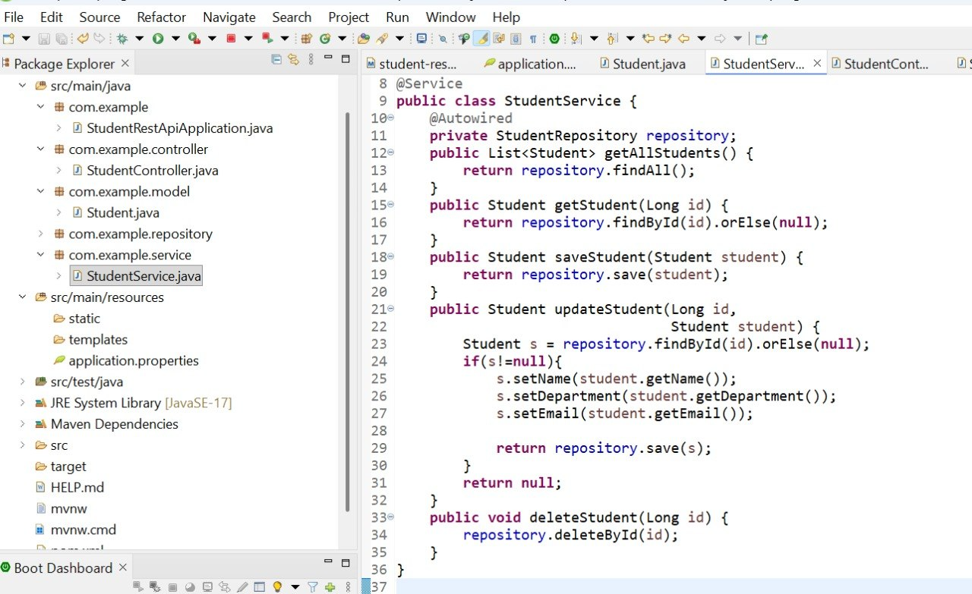
Step 8:
Create class file StudentController.java in com.example.Controller Layer and save it.
package com.example.controller;
import java.util.List;
import org.springframework.beans.factory.annotation.Autowired;
import org.springframework.http.ResponseEntity;
import org.springframework.web.bind.annotation.*;
import com.example.model.Student;
import com.example.service.StudentService;
@RestController
@RequestMapping("/students")
public class StudentController {
@Autowired
private StudentService service;

@GetMapping
public List<Student> getAllStudents() {
return service.getAllStudents();
}
@GetMapping("/{id}")
public ResponseEntity<Student> getStudent(
@PathVariable Long id){
Student student=service.getStudent(id);
if(student==null)
return ResponseEntity.notFound().build();
return ResponseEntity.ok(student);
}
@PostMapping
public Student addStudent(
@RequestBody Student student){
return service.saveStudent(student);
}
@PutMapping("/{id}")
public ResponseEntity<Student> updateStudent(
@PathVariable Long id,
@RequestBody Student student){
Student updated=service.updateStudent(id,student);
if(updated==null)
return ResponseEntity.notFound().build();

return ResponseEntity.ok(updated);
}
@DeleteMapping("/{id}")
public ResponseEntity<String> deleteStudent(
@PathVariable Long id){
service.deleteStudent(id);
return ResponseEntity.ok("Deleted Successfully");
}
}
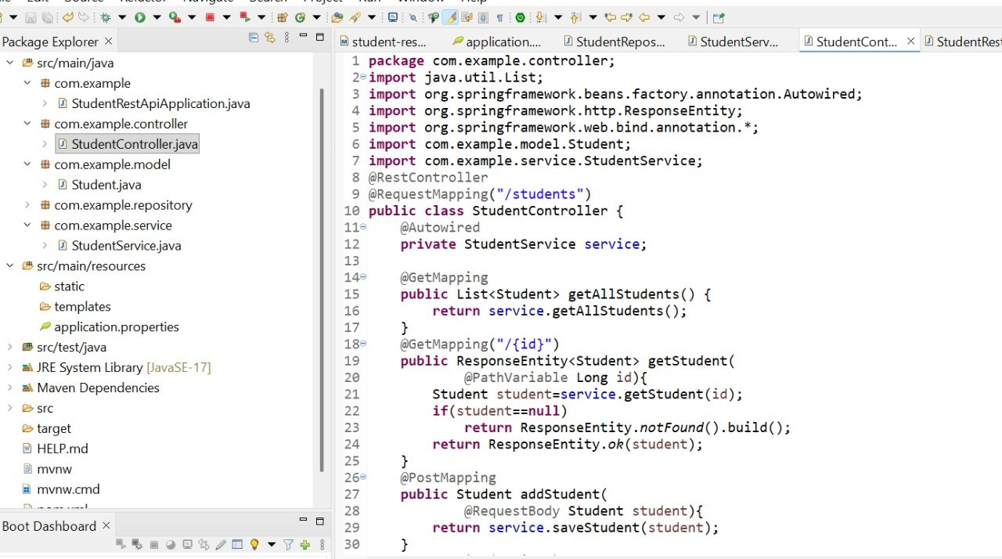
Step 9:
- Start MySQL Server

- Create Database StudentDb;
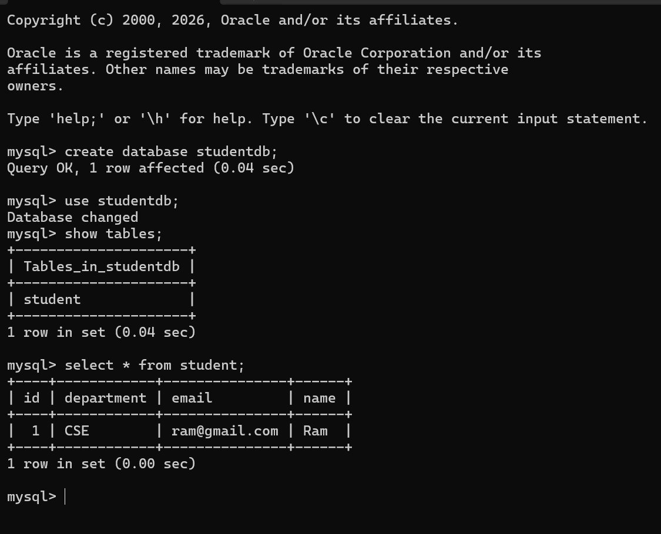

Step 10:
Run as SpringBoot App
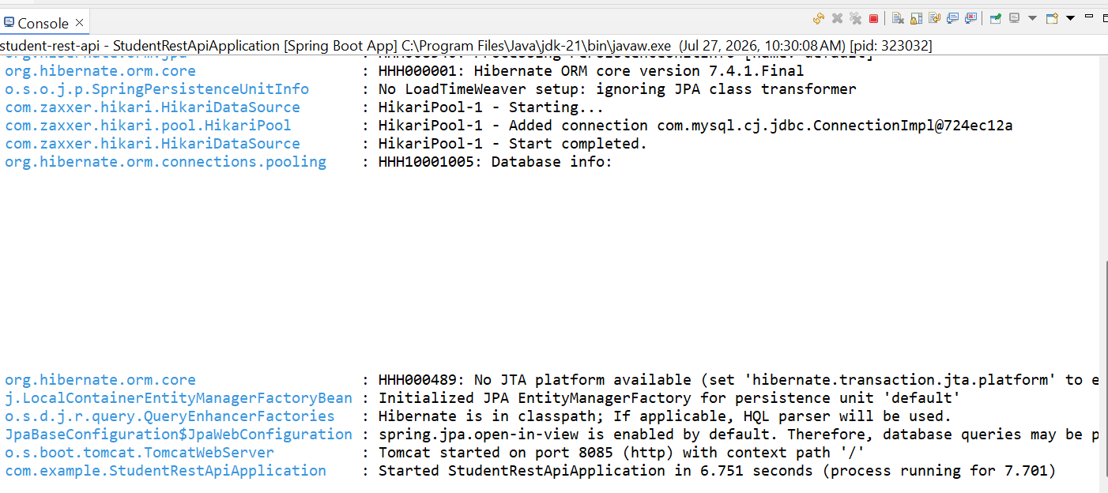
Step 11:
Open Postman app,
Testing GET method with Postman
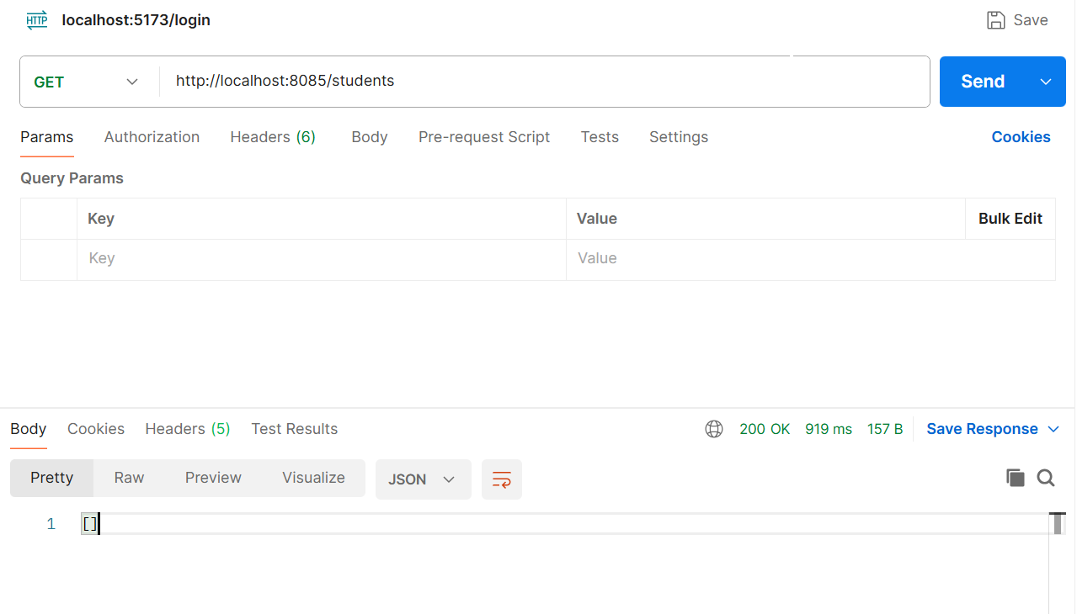
Since there are no data in the table, it returned empty braces.
Testing POST method with Postman
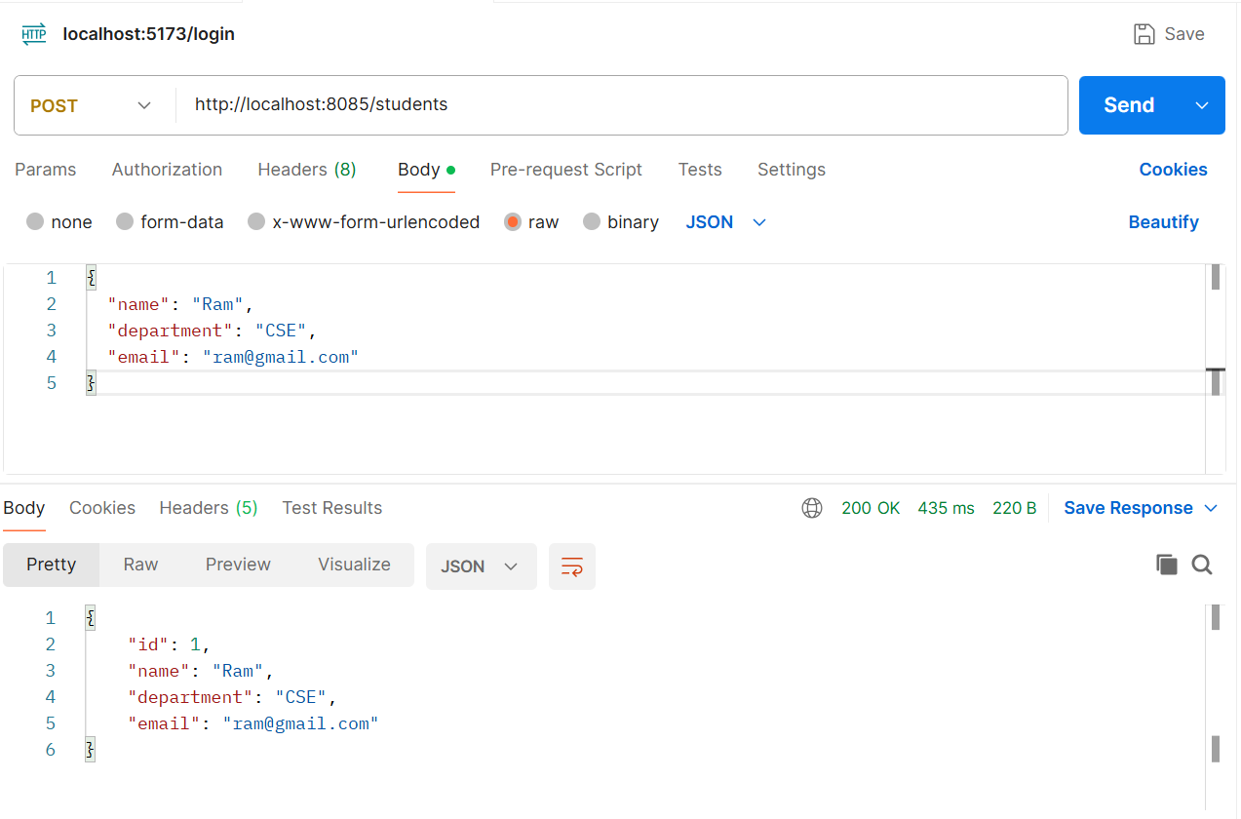
Now, inserted on row into the table using POST method. Test it with GET method to retrieve the data.
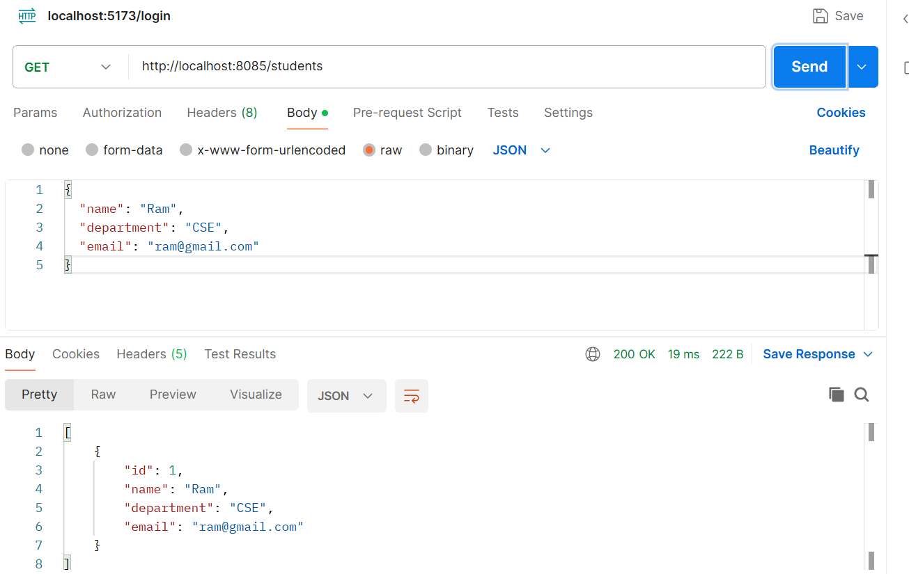
Step 12:
Now test it with MySQL Server
- Use Studentdb;
- Show Tables;
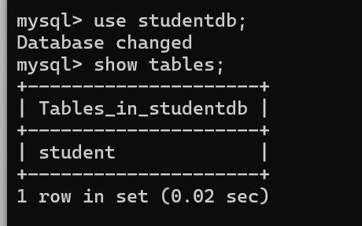

- Now verify, whether the row inserted using POST method in POSTMAN is visible in Database.
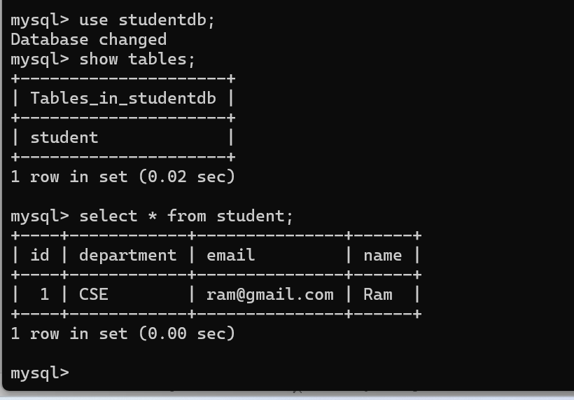
Likewise test other methods PUT and DELETE.

Step 13:
Testing with cURL:
cURL stands for Client URL. It is a command-line tool used to send HTTP requests to a web server or REST API. It allows developers to test APIs without using a graphical interface like Postman.
Why use cURL?
- Test REST APIs from the terminal.
- Send HTTP requests (GET, POST, PUT, DELETE).
- Debug backend services.
- Automate API testing in scripts.
Run in Command Prompt:
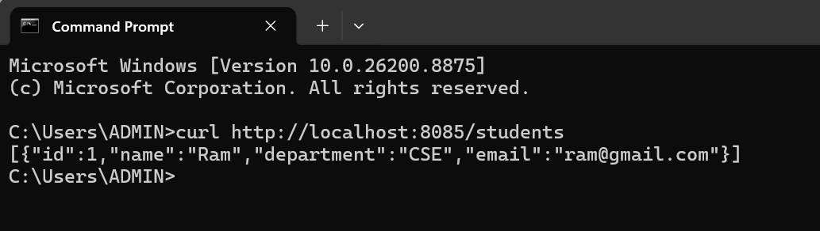
Create a student:
curl -X POST http://localhost:8085/students -H "Content-Type: application/json" -d "{\"name\":\"Ramya\",\"department\":\"CSE\",\"email\":\"ramya@gmail.com\"}"
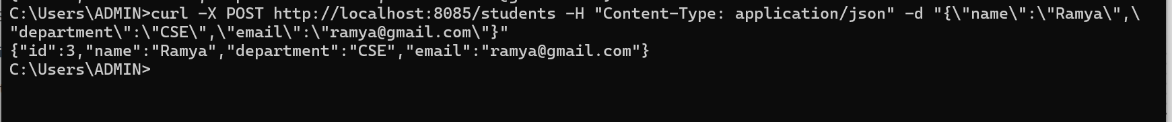
Check all the students details:

